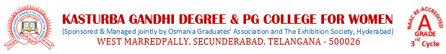
5.3.2 Clarification
S. No | A.Y | No. of awards | Link to list of sports and cultural activity | Link to Certificates of sports and cultural activity
1 | 2021-22 | 12 | 2021-22 List of sports and cultural activities | 2021-22- Certificates -sports and cultural activities
2 | 2020-21 | 9 | 2020-21 List of sports and cultural activities | 2020-21- Certificates -sports and cultural activities
3 | 2019-20 | 33 | 2019-20 List of sports and cultural activities | 2019-20- Certificates -sports and cultural activities
4 | 2018-19 | 21 | 2018-19 List of sports and cultural activities | 2018-19- Certificates -sports and cultural activities
5 | 2017-18 | 9 | 2017-18 List of sports and cultural activities | 2017-18- Certificates -sports and cultural activities
 | Total | 84
